GENERAL INSTRUCTIONS FOR AUTHORS

- Prepare your contribution according to the following Guidelines:

Título Título Título Título Título Título Título Título (español)
Author One
authorone@xxxxmail.yyy
https://orcid.org/register
Name of the Institution (initial letters or acronym) of affiliation of the Author One
City, Country

Author Two
authortwo@xxxxmail.yyy
https://orcid.org/register
Name of the Institution (initial letters or acronym) of affiliation of the Author Two
City, Country

Author Three
authorthree@xxxxmail.yyy
https://orcid.org/register
Name of the Institution (initial letters or acronym) of affiliation of the Author Three
City, Country
Received: day/month/year Accepted: day/month/year
Resumen (español)
En este trabajo presentamos una síntesis de la reconstrucción del significado global de la derivada que hemos realizado con la ayuda de algunas herramientas teóricas del enfoque ontosemiótico del conocimiento y la instrucción matemática. Así mismo, caracterizamos el significado pretendido en el currículo de Bachillerato a partir de las prácticas matemáticas propuestas tanto en el Plan de Estudios como en los libros de texto de dicho nivel. La comparación de ambos significados (global y curricular) permite valorar la idoneidad epistémica del significado curricular. La metodología de análisis didáctico aplicada para el caso de la derivada en el currículo (Plan de Estudios y libros de texto) mexicano, se puede aplicar a otros contenidos y contextos. La información aportada puede ser útil para el profesor de matemáticas de bachillerato ya que revelamos algunos sesgos en los significados de la derivada privilegiados por el currículo que podrían ser evitados para mejorar la enseñanza de la derivada.
Palabras-clave: Derivada. Significado Global. Currículo de Matemáticas. Conocimiento del Profesor. Enfoque Ontosemiótico.
Title Title Title Title Title Title Title Title (english)
Abstract
In this paper, we report a synthesis of a reconstruction of the derivative holistic meaning carried out using some theoretical notions of the onto-semiotic approach. We characterize the intended high school curricular meaning of the derivative, based on the mathematical practices proposed in both the core curriculum and the textbooks. The comparison between the global and curricular meanings allows assessing the “epistemic suitability of curricular meaning”, intended for the high school curriculum. The methodology of the didactical analysis, applied to the case of the derivative in the Mexican curriculum and textbook can be extended to other contents and contexts. The information provided may be useful for high school mathematics teacher because we reveal some biases in the meanings of the derivative privileged by the curriculum that could be avoided to improve the teaching of the derivative.
Keywords: Derivative. Holistic Meaning. Mathematics Curriculum. Teacher Knowledge. Ontosemiotic Approach.

Título Título Título Título Título Título Título Título (portugués)
Resumo (português)
Neste trabalho apresentamos uma síntese da reconstrução do significado global da derivada que nós realizamos como ajuda de algumas ferramentas teóricas do enfoque ontossemiótico do conhecimento e da instrução matemática. Além disso, fizemos a caracterização do significado pessoal pretendido no currículo do bacharelado partindo das práticas matemáticas propostas tanto no Plano de estudos quanto nos livros de texto desse nível. A comparação dos dois significados (global e curricular) permite valorizar a idoneidade epistémica do significado curricular. A metodologia da análise didática aplicada para o caso da derivada no currículo (Plano de estudos e livros de texto) mexicano, pode ser aplicada a outros conteúdos e contextos. A informação aportada pode ser útil para o professor de matemática de bacharelado porque foram revelados alguns sesgos nos significados da derivada privilegiados pelo currículo que poderiam se evitar para melhorar o ensino da derivada.
Palavras-chave: Derivada. Significado Global. Currículo de Matemáticas. Conhecimento do Profesor. Enfoque Ontossemiótico.

Guidelines for the format of the manuscript
- Primary Sections (Times New Roman, size 12, bold, justified, only the initial in capital letters)
The text in the body of the article must be in Times New Roman font, size 12, justified, spacing 1.5 lines; indentation 1.25 in the first line of the paragraphs, letter size paper; mirror margins; different odd and even pages, different on the first page, top, bottom and outer margins, 2.5; internal margin, 3.0; no spaces before or after paragraphs. The text must have a minimum of 20 pages and a maximum of 25 pages, and the annexes are not considered in this number of pages.
PAGE CONFIGURATION
PARAGRAPH CONFIGURATION
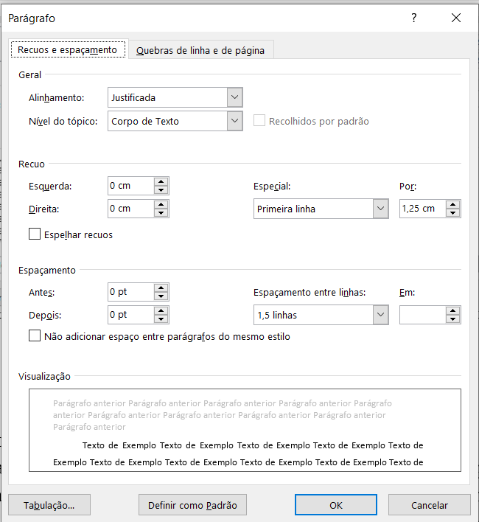
- ORCID iD Registration
All authors must have ORCID Id Registration, that is a requirement of Paradigma Journal indexers (to obtain ORCID code, just register at https://orcid.org/register).
- Metadata
It is mandatory to provide all the information about the authors in the MANUSCRIPT METADATA on the journal website when the article is registered, indicating the ORCID links, the lattes curriculum (if applicable) and other useful information about all the authors.
- Highlighting words in the text
To highlight words/phrases in the text, use only letters in italics, that is, you should not use bold or underlining to highlight text. After each section, you must give a line break (ENTER).
- Footnotes
For footnotes: Times New Roman font, size 10, single line spacing, justified paragraph. It is suggested that footnotes be avoided whenever possible. If they are strictly necessary, they must be numbered with Arabic numerals.
- Secondary sections (Times New Roman, size 12, bold, justified)
The text in these sections of the article must be in Times New Roman font, size 12, justified, spacing 1.50 lines; indentation 1.25 in the first line of the paragraphs, letter size paper; no spaces before or after paragraphs.
- The citations in the body of the article
Direct citations with more than 40 words should be made like this: indentation of 4 cm from the left margin, single spacing, without quotes, Times New Roman font, size 10. In indirect citations, in the body of the article, the names of the authors must be referred using capital letters (initial) and lower case. If they are in parentheses, they must be digitized in capital letters. For example: Villegas (2021) or (VILLEGAS, 2021).
- Tertiary sections (Times New Roman, size 12, justified)
The text in these sections of the article must be in Times New Roman font, size 12, justified, spacing 1.50 lines; indentation 1.25 in the first line of the paragraphs, letter size paper; no spaces before or after paragraphs.
- Theoretical reference
Reference should be given to recent publications (less than five years old, current); In the case of sources older than five years, there must be certainty of the validity of their content or the relevance according to the matter being studied. It is recommended to review previous editions of Paradigma, other specialized and indexed journals, books, master’s degree projects, doctoral theses and memoirs (proceedings) of events specific to the field of research reported in the manuscript. Authors of articles from Brazil must use the ABNT Standards; those from other latitudes can use the APA Standards.
- Methodology
Paradigma is a multi-perspective and multi-paradigmatic journal, so the articles to be published can be derived from qualitative, quantitative or mixed research. In any case, this section must account for the following aspects of the strategy used to define, obtain, record, organize, treat and produce the information necessary to guarantee the suitability of the study: approach, focus, or perspective; nature of the study in accordance with its intention and the type of question that generated the research; characterization of research participants; place where it was carried out (protecting of course the real identity, whenever necessary), techniques, instruments, procedures, context, environment and other elements that are necessary for the adequate understanding of the study.
- Figures, Charts, Tables and other graphic elements
Figures and tables should be as close as possible to their mention in the body of the text. The title of the figures must be sufficiently clear in relation to the image, so that it is not necessary to consult the body of the text. Only the number of the object and the word used to designate it should be in bold. The titles of the figures should be like this: Times New Roman font, size 12, single spacing. The font is Times New Roman, size 10, single spaced. Always mention the source.
Figure 1 - Title of the figure
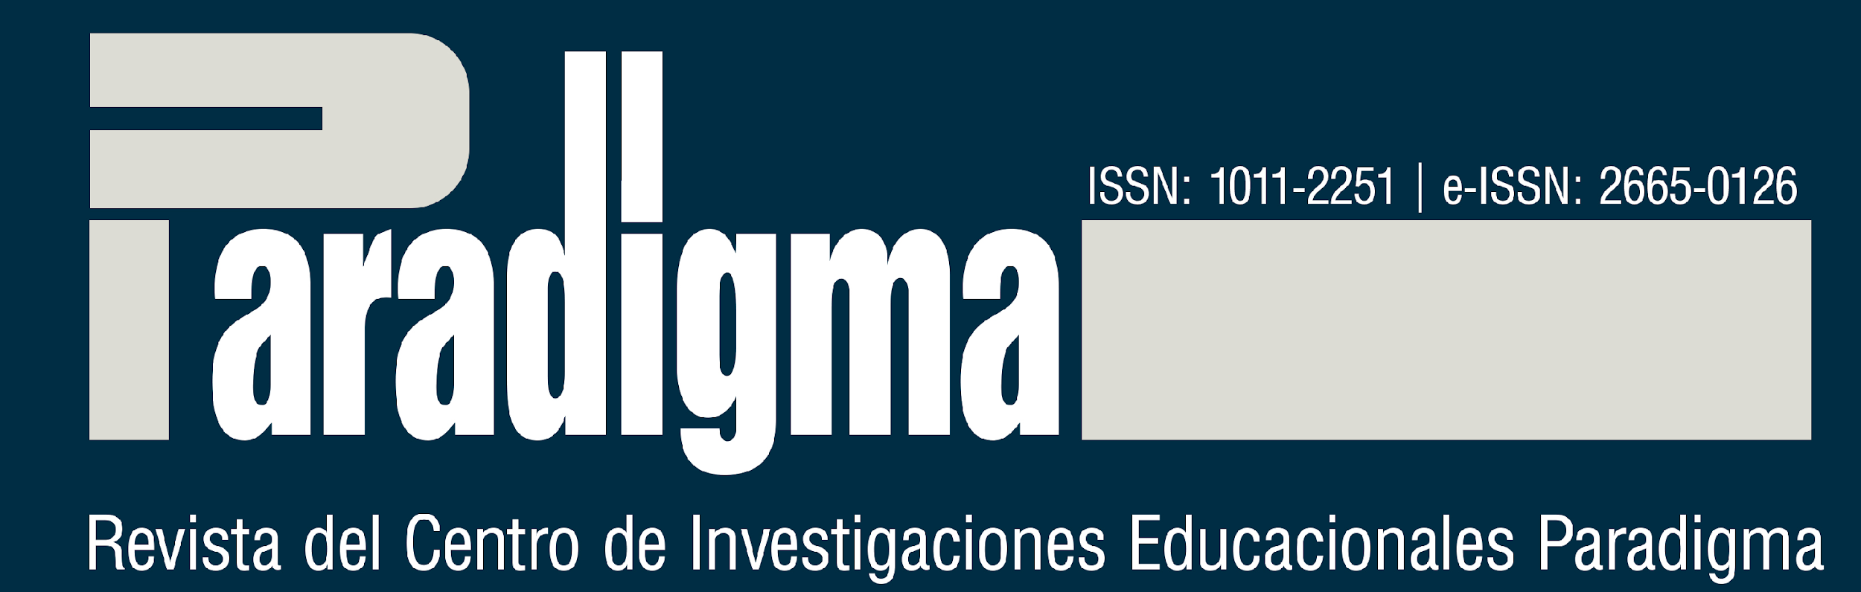
Source: Name of the source or surname of the author (year, p. xx)

Use a good resolution, so that the figure is readable by readers at 100% zoom, always respecting the margins of the document.
In relation to the tables, the indications are as follows: Times New Roman font, size 10, single spacing. Table titles must be written like this: Times New Roman font, size 12, single spaced. Fonts must be in Times New Roman font, size 10, single spacing. Always mention the source.
Example:
Table 2 - Student’s justifications in the sum of the results when throwing two dice
Tasks | Student answers  (A)
An even number? | Possible
An odd number? | Possible
Number 1? | There is a possibility
Source: Mendes (year, p. xx); Elaboration based on Mendes (year, p. xx); Elaboration by author(s)
Tables are ways of presenting quantitative information, made up of numerical data. The identification of the tables must be at the top, preceded by the word Table (in bold), followed by their number of order of appearance in the text, in Arabic numerals (in bold), then insert the respective title (without bold). ). The title and the content of the tables must be written in Times New Roman font, size 12. The title must be separated from the respective numbering by a “-”. The source must always be mentioned. The table should be inserted in the place in the text as close as possible to where it was mentioned in the text. Sources and notes must be digitized in Times New Roman font, size 10, with simple line spacing.
Example 1:
Table 1 - Distribution of the Height of 140 of School X
Heights (cm) | Number of students
[145, 150] | 2
[150, 155] | 8
[155, 160] | 25
[160, 165] | 40
[165, 170] | 27
[170, 175] | 21
[175, 180] | 10
[180, 185] | 7
Total | 140
Source: Mendes (year, p. xx); Elaboration based on Mendes (year, p. xx); Elaboration by author(s)
Example 2:
Table 1 - Varieties of Qualitative Research indicated in the theses
Item | Quantity | Percentage
Investigation action | 2 | x%
Ethnography | 3 | x%
Oral history | 5 | x%
Autobiographical narratives | 12 | x%
IAP | 3 | x%
Dialogic inquiry | 0 | x%
Total | 25 | x%
Source: Mendes (year, p. xx); Elaboration based on Mendes (year, p. xx); Elaboration by author(s)

Charts, tables and equations must be in a format that can be edited. Images are not accepted. The use of expressions such as “the Table above” or “the Figure below” should not be used, because at the time of formatting the manuscript their place can be altered.
All tables must have a title indicative of the nature and geographical and temporal scope of the numerical data, in full, without abbreviations, clearly and concisely. It must have a number (Arabic, increasing) whenever there are two or more tables in the document.
Regarding the visual aspect of the table, it should not have vertical lines that delimit it to the left and right. It must contain the numerical data within the cells, for information on the quantification of the specific observed fact. It must be prepared in such a way that it occupies a single page and that it represents graphic uniformity (font type, body, use of upper and lowercase letters).
- Analysis and Results
They must be developed from the theoretical and methodological framework, considering the necessary requirements to guarantee originality, scientificity, rigor and precision.
- Conclusions (Or Final considerations/Final reflexions)
Highlight the author’s conclusions and/or positions regarding the results of the study, articulated with the research questions and based on the problem studied.
- Acknowledgments (when any, it is not mandatory)
They must observe the same rules used in the body of the text.
- References
Below are examples of references of various types.

Examples:
Books with 1 author:
BURKE, P. O que é história do conhecimento? Translated by Cláudia Freire. São Paulo: Editora da UNESP, 2016.
CAVEING, M. Le problème des objets dans la pensée mathématique. Paris: Librairie Philosophique J. Vrin, 2004.

Books with 2 authors:
MENDES, I. A.; STAMATTO, M. I. S. Escolas Normais do Brasil: espaços de (trans)formação docente e produção de saberes profissionais. São Paulo: Ed. Livraria da Física, 2020.

Books with 3 authors:
MENDES, I. A.; MACHADO, B. F.; SOARES, E. C. Aritméticas lúdicas em sala de aula. Belém: Sociedade Brasileira de História da Matemática, 2016.

Books with more than 3 authors:
MENDES, I. A.; [Inform all the authors]. Ciências da educação, campos disciplinares e profissionalização: saberes em debate para a formação de professores. São Paulo: Ed. Livraria da Física, 2020.

Books by editors, coordinators or organizers:
OLIVEIRA, A. M. P. de.; ORTIGÃO, M. I. R. (Org.). Abordagens teóricas e metodológicas nas pesquisas em Educação Matemática. Brasília: SBEM, 2018. (Collection SBEM). Available at: http://www.sbembrasil.org.br/files/ebook.pdf. Accessed on: 20 Jan. 2020.
CYRINO, M. C. de C. T. (Org.). Temáticas emergentes de pesquisas sobre a formação de professores que ensinam matemática: perspectivas e desafios. Brasília: SBEM, 2018. (Colection SBEM). Available at: http://www.sbembrasil.org.br/files/tematicas_ emergentes. pdf. Accessed on: 20 Jan. 2020.
Master’s degree projects, doctoral theses, course completion projects:
CAVALCANTE, L. G. M. Experiência estética com formas geométricas nos anos iniciais. 2019. Thesis (Master) – Universidade Federal do Pará, Belém, 2019. Available at: http://gpsem.online/dissertacoes. Accessed on: 20 Jan. 2020.
KHIDIR, K. S. Práticas socioculturais quilombolas para o ensino de matemática: mobilizações de saberes entre comunidade e escola. 2018. Dissertation (Doctoral) – Universidade Federal do Pará, Instituto de Educação Matemática e Científica, Programa de Pós-Graduação em Educação em Ciências e Matemáticas, Belém, 2018. Available at: http://gpsem.online/teses. Accessed on: 20 Jan. 2020.
Works presented at events:
ALVARADO PRADA, L. E. A. Metodologias de pesquisa-formação de professores nas dissertações, teses: 1999-2008. In: IX Seminário Nacional de Pesquisa em Educação da Região Sul. Anais do IX ANDEP SUL – Seminário Nacional de Pesquisa em Educação da Região Sul, 2012. Available at: http://www.ucs.br/etc/conferencias/index.php/anpedsul/ 9anpedsul/paper/viewFile/3179/482. Accessed on: 20 Jan. 2020.

Magazine/Newspaper Articles:
BURGOS, C. C. H.; GONZALEZ, F. E. Espacios de formación complementaria de los educadores matemáticos venezolanos. Caso: Escuela Venezolana para la Enseñanza de la Matemática – EVEM. História da Educação, v. 24, e99353, 2020. Available at: http:// www.scielo.br/scielo.php?script=sci_arttext&pid=S2236-3459202000010 0504&lng=en&nrm=iso. Accessed on: 31 Jan. 2021.

GONZÁLEZ, F. Dificultades en la realización de trabajos de investigación: cómo afrontarlas. Práxis Educacional, v. 11, n. 18, p. 275-300, 2014. Available at: https:// periodicos2.uesb.br/index.php/praxis/article/view/812. Accessed on: 31 Jan. 2021.

PIRES, L. S.; MENDES, I. A. História da matemática no ensino fundamental nos livros de minicursos da SBHMat (2001-2017). Revista Prática Docente, v. 5, n. 1, p. 28-44, 2020. Available at: http://periodicos.cfs.ifmt.edu.br/periodicos/index.php/rpd/article /view/575. Accessed on: 1st. May 2020.

Research Projects
MENDES, I. A. História para o ensino de matemática na formação de professores e na educação básica: uma análise da produção brasileira (1997– 2017). Projeto de Pesquisa Produtividade CNPq. Belém: Universidade Federal do Pará, 2018.

Legal Documents
BRASIL. Lei n.º 9394/96. Lei de Diretrizes e Bases da Educação Nacional. Estabelece as diretrizes e bases da educação nacional. Brasília, 1996. Available at: https://www. planalto.gov.br/ccivil_03/Leis/L9394.htm. Accessed on: 25 May 2019.
BRASIL. Ministério da Educação. Parecer CNE/CES nº 1.302, de 06 de novembro de 2001. Define as Diretrizes Curriculares Nacionais para os Cursos de Matemática, Bacharelado e Licenciatura. Brasília, 2002b. Available at: http://portal.mec. gov.br/cne/arquivos/pdf/CES13022.pdf. Accessed on: 25 May 2019.
BRASIL. Ministério da Educação. Resolução CNE/CP nº. 1, de 18/02/2002. Institui Diretrizes Curriculares Nacionais para a Formação de Professores da Educação Básica, em nível superior, curso de licenciatura, de graduação plena. Brasília, 2002. Available at: http://portal.mec.gov.br/cne/arquivos/pdf/rcp01_02.pdf. Accessed on: 25 May 2019.
BRASIL. Ministério da Educação. Resolução CNE/CP nº. 2, de 19 de fevereiro de 2002. Institui a duração e a carga horária dos cursos de licenciatura, de graduação plena, de formação de professores da Educação Básica em nível superior. Brasília, 2002c. Available at: http://portal.mec.gov.br/cne/arquivos/pdf/CP022002.pdf. Accessed on: 25 May 2019.
- Links
All electronic addresses (links) of INTERNET pages (URLs) included in the text must respect the rights of the corresponding authors.

- Data of the authors
Authors
Name and Surnames of the Author 1
Graduation Diploma and institution where it was obtained
Master’s Diploma and institution where it was obtained
Doctoral Diploma and institution where it was obtained
Work institution
Group and Line of Research
brown xxx@gmail.com
https://orcid.org/0000-0000-0123-4567

Name and Surnames of the Author 2
Graduation Diploma and institution where it was obtained
Master’s Diploma and institution where it was obtained
Doctoral Diploma and institution where it was obtained
Work institution
Group and Line of Research
brown xxx@gmail.com
https://orcid.org/0000-0000-0123-4567
Name and Surnames of the Author 3
Graduation Diploma and institution where it was obtained
Master’s Diploma and institution where it was obtained
Doctoral Diploma and institution where it was obtained
Work institution
Group and Line of Research
brown xxx@gmail.com
https://orcid.org/0000-0000-0123-4567
- How to cite the article
SURNAME 1, A. B.; SURNAME 2, C. D; ...; SURNAME X, X. X. Title in Main Language Title in Main Language Title in Main Language Title in Main Language Title in Main Language. Revista Paradigma, Vol. XLIV, Nro. 2, julio de 2023 / pi – pf. DOI 10.37618/PARADIGMA.1011-2251.2023.pxy-wz.id0000
- Annexes
When necessary, the annexes must go on a new page.

